1. Find the Minimum Marks and Maximum marks scored by each student.

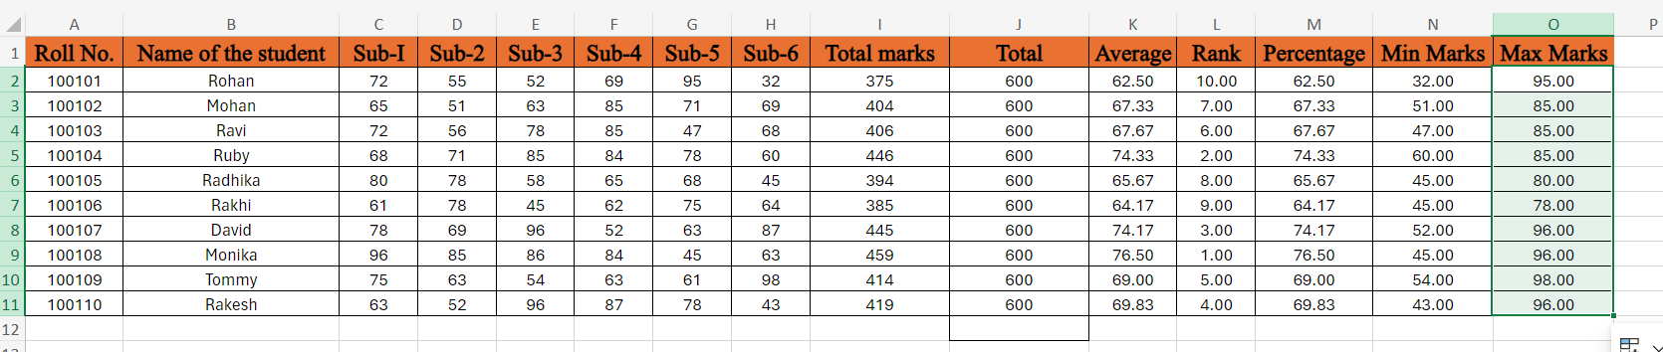

1. Calculate the totals for each student, use conditional formatting to

highlight the top students who have scored more than 480.

No student scored more than 480.

1. Calculate the length of the names of each student.

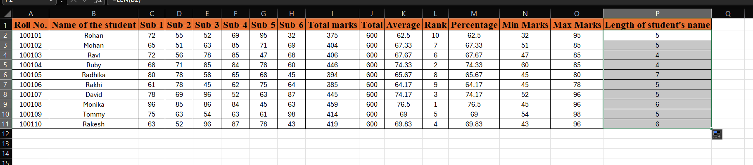

1. Replace the Name Rakhi with Rocky. Use Formulas

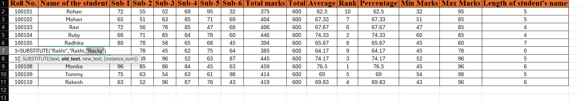

1. Combine the Roll Numbers and Names. Use formulas. The end result

should look like below.

100101Rohan

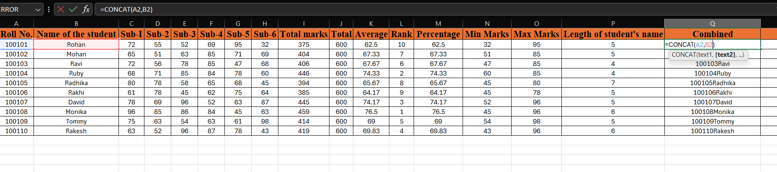

1. As you can see that some names have spacing issues. Use Formulas

to correct that spacing. Also ensure that the names and surname start with a capital letter

